For each simulation: 100 Y realizations, 100 sets of 50 RV/realization

**LMM method: continuous response (15000 permutations, 2-sided VT test)**

**Y= 1.5 + .5 gender + .05 age + E where E is N(0, 4Φ+ 25 I )**

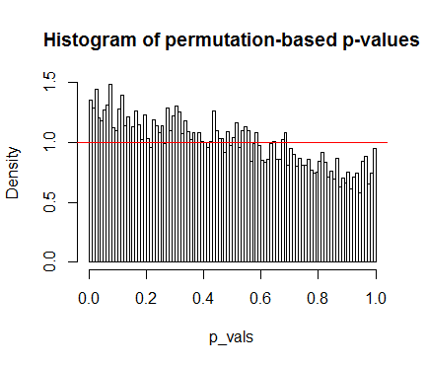

**EE method: liability threshold model for Y (15000 permutations, 1-sided VT)**

**Liab= 1.5 + .5 gender + .05 age + E where E is N(0, Φ+ 25 I )**

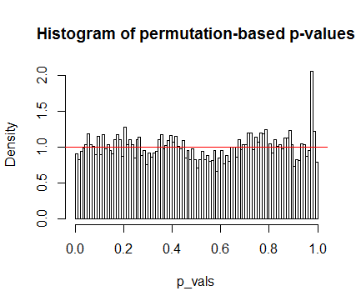

alpha Err_rate p_value

0.005 0.0044 0.4355267

0.010 0.0091 0.3929487

0.050 0.0469 0.1616823

**EE method: logistic model for Y (15000 permutations, 1-sided VT)**

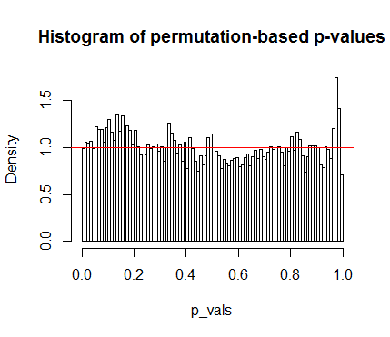**Logit(mean)= b0 + .5 gender + .05 age + E where E is N(0, Φ)**

alpha Err_rate p_value

0.005 0.0049 0.9434868

0.010 0.0099 0.9599217

0.050 0.0516 0.4769673

**EE method: logistic model for Y (25000 permutations, 1-sided VT)**

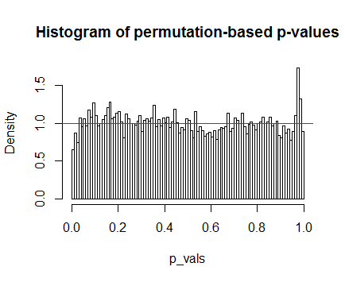**Logit(mean)= b0 + .5 gender + .05 age + E where E is N(0, 0.1*Φ)**

alpha Err_rate p_value

0.005 0.0034 0.0279825

0.010 0.0067 0.0010893

0.050 0.0429 0.0012174

**EE method: logistic model for Y (15000 permutations, 1-sided VT family based stat)**

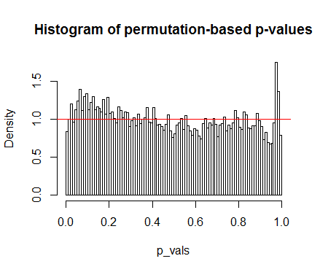**Logit(mean)= b0 + .5 gender + .05 age + E where E is N(0, Φ)**

alpha Err_rate p_value

0.005 0.0041 0.2281655

0.010 0.0084 0.1192786

0.050 0.0515 0.5058550

**EE method: logistic model for Y (25000 permutations, 2-sided VT family based stat)**

**Logit(mean)= b0 + .5 gender + .05 age (no additive polygenic effect)**

